28 March 2007, Geneva
State Responses to the report by John Ruggie,
Special Representative of the UN Secretary-General for business and human rights,
at the United Nations Human Rights Council

This document was prepared by Business & Human Rights Resource Centre

John Ruggie’s response to questions/comments from governments at the UN Human Rights Council (video)

Argentina 2
Belgium 3
Canada 4
Cuba 5
France 6
Germany 9
Indonesia 10
Norway 11
Pakistan 12
Switzerland 13
United Kingdom 15
United States of America 16

Argentina

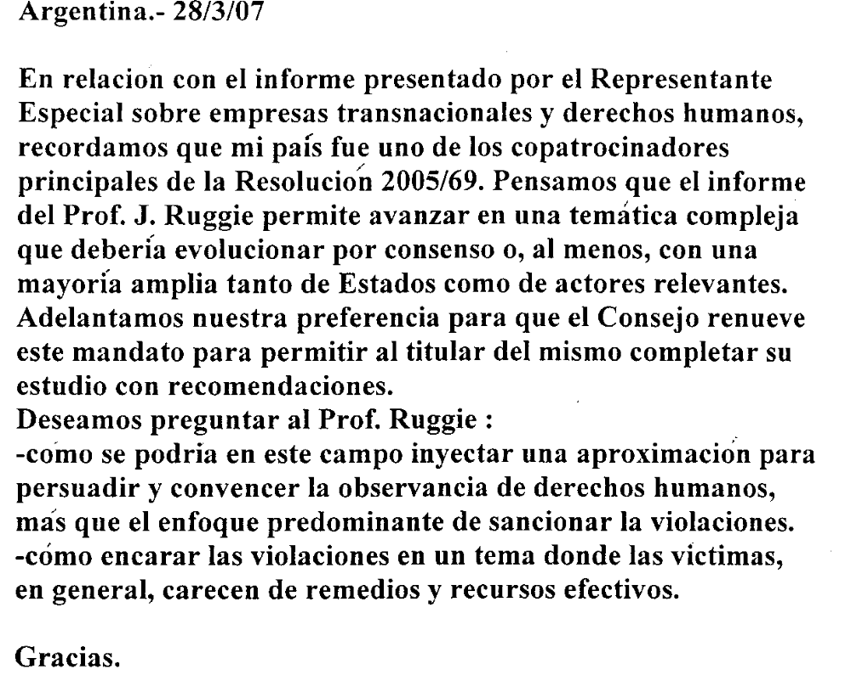

Belgium

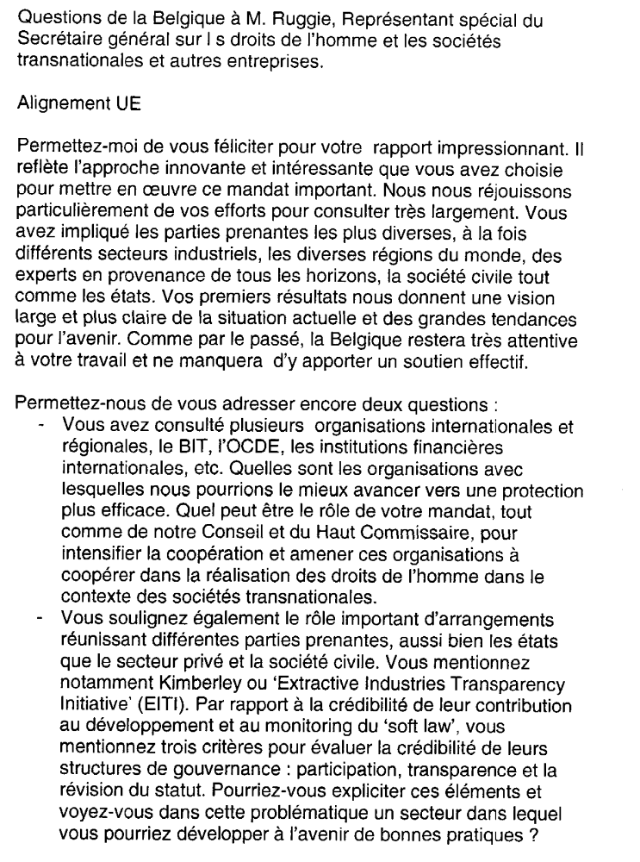

Canada

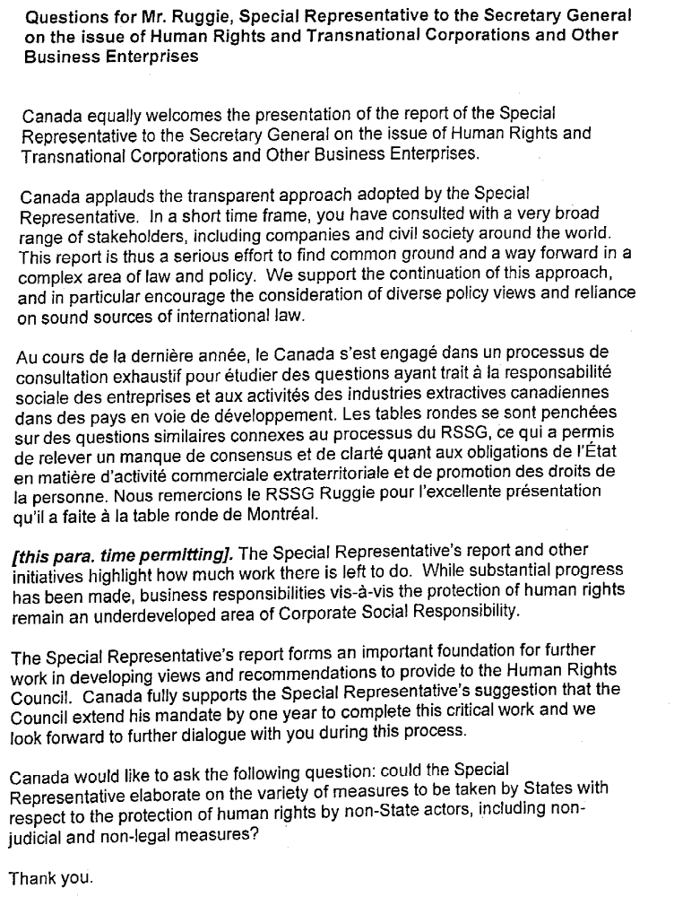

Cuba

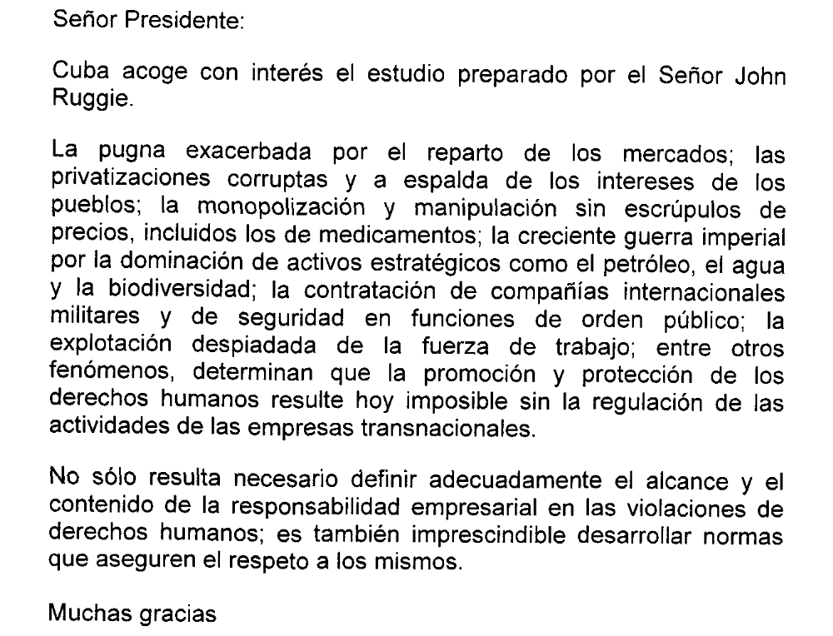

France
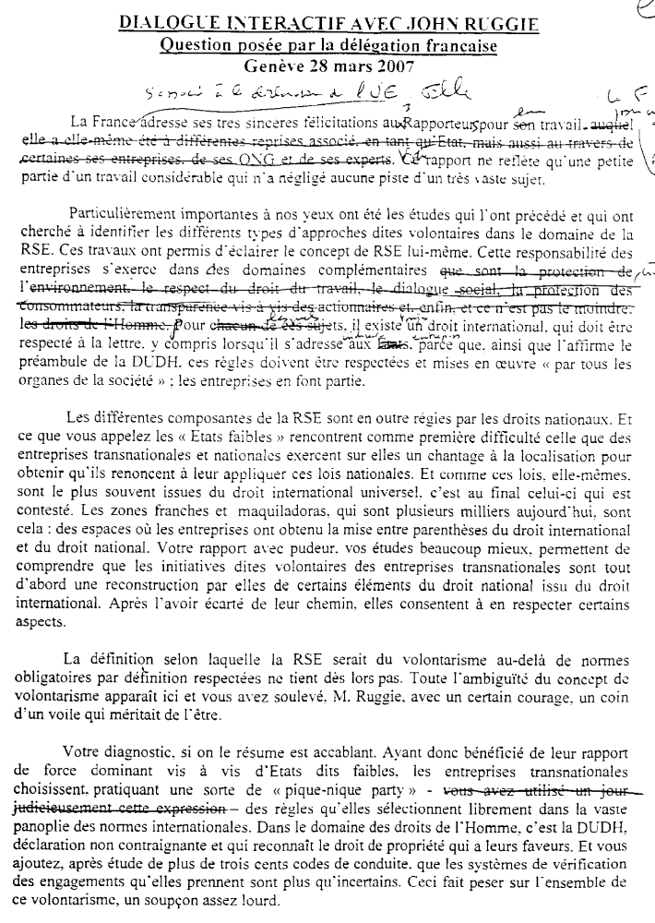
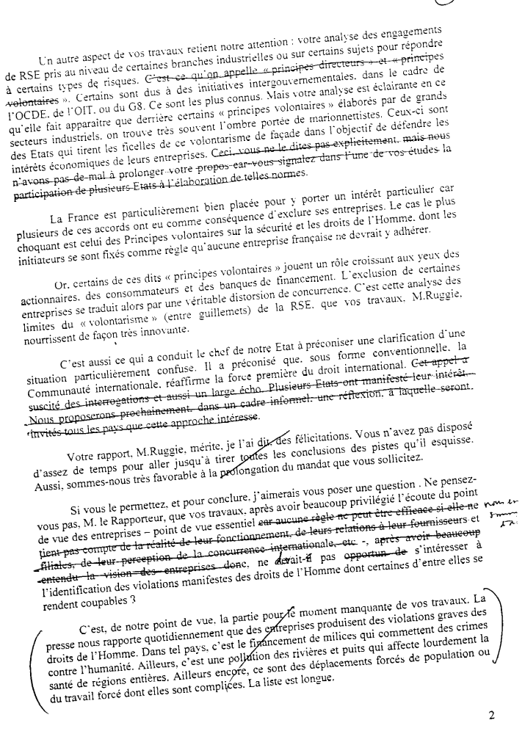

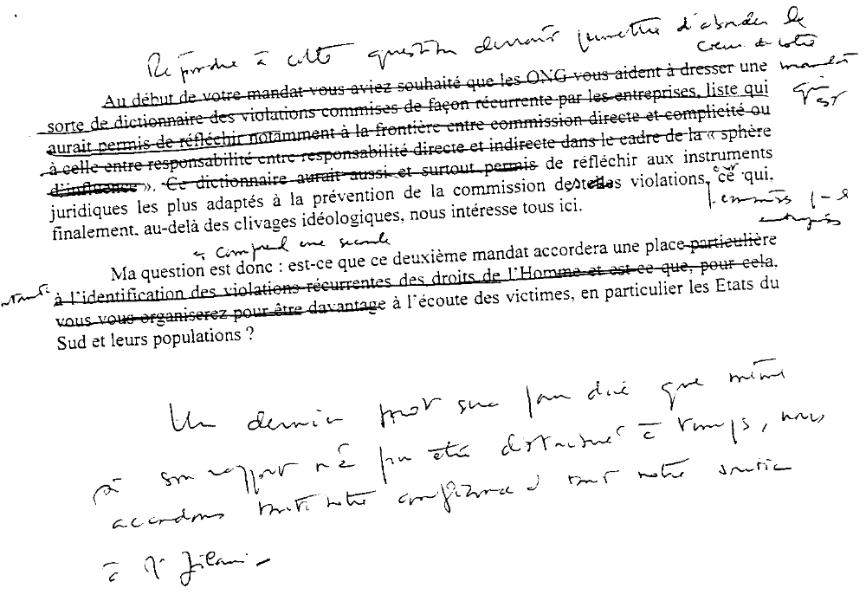

Germany

Indonesia

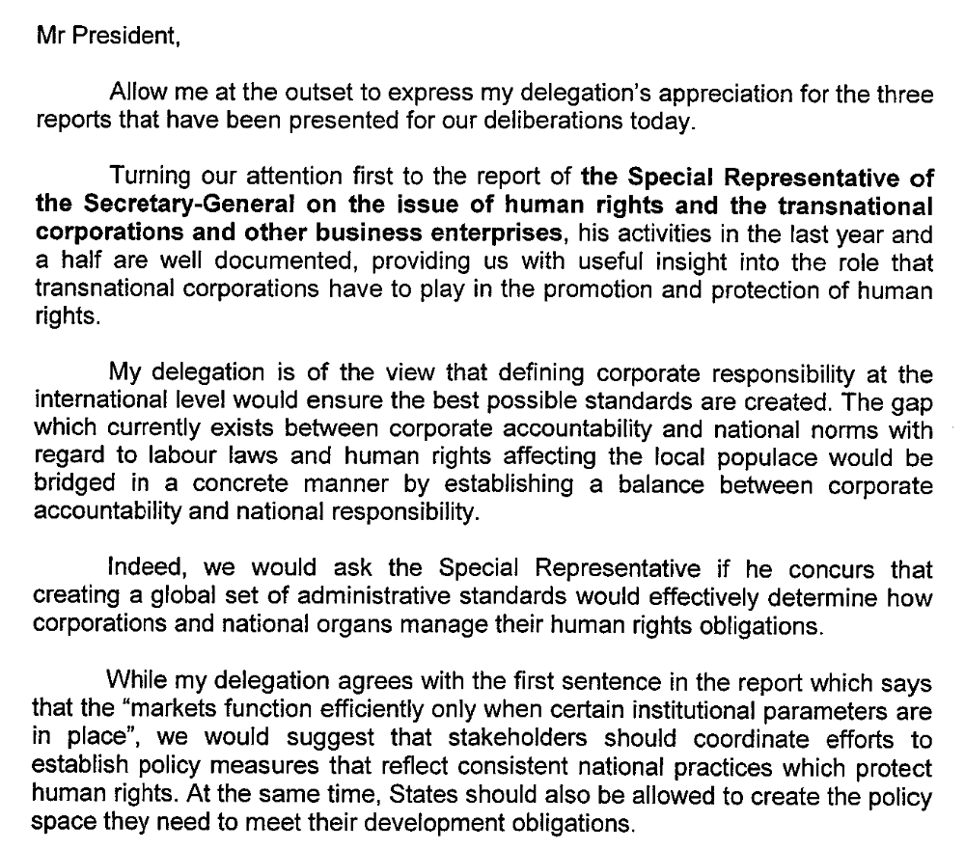

Norway

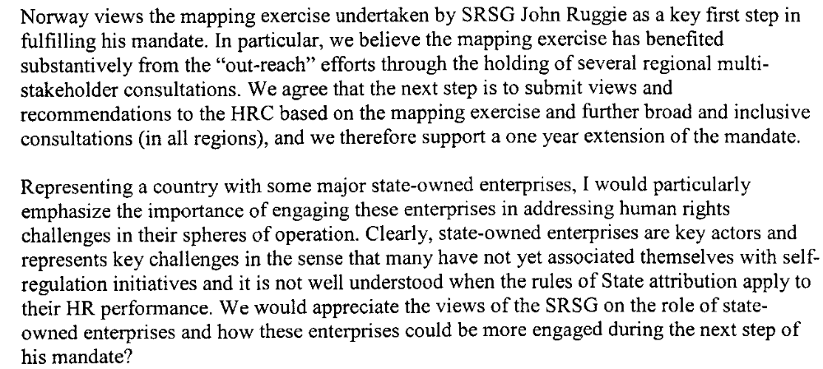

Pakistan

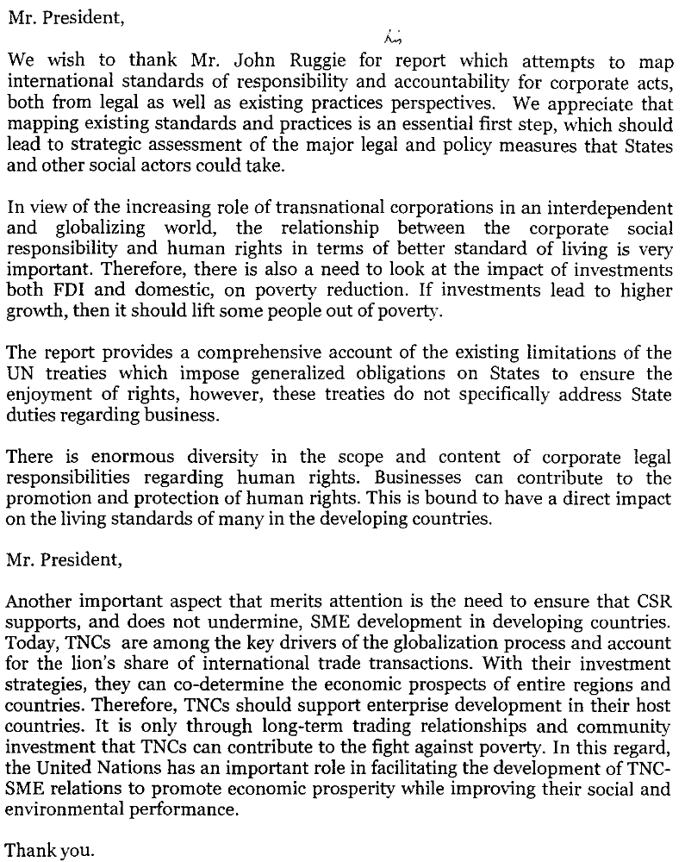

Switzerland

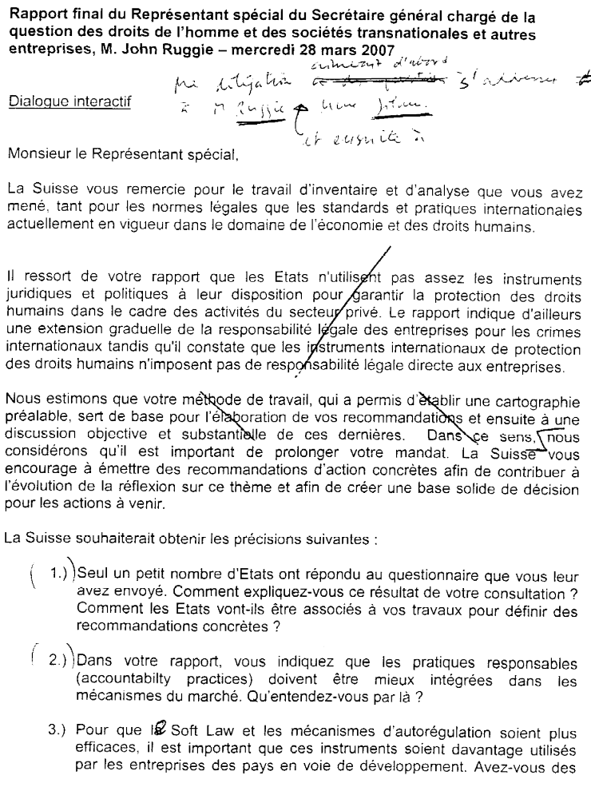
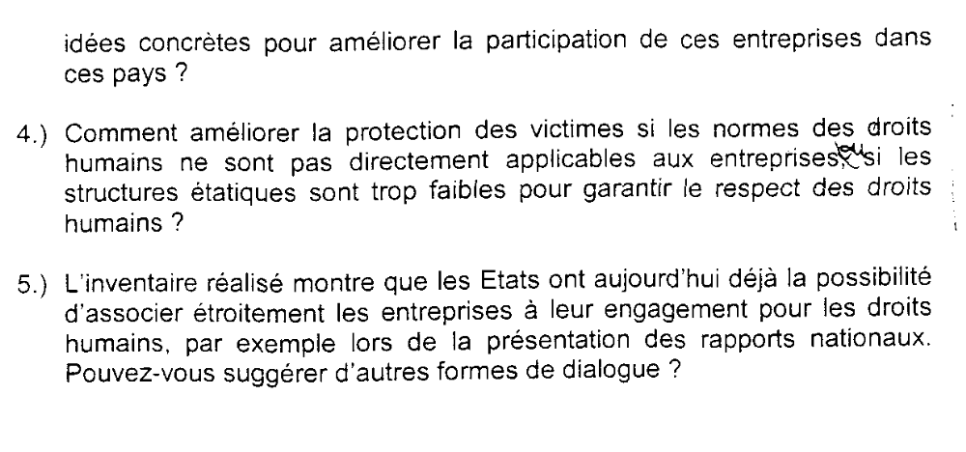

United Kingdom

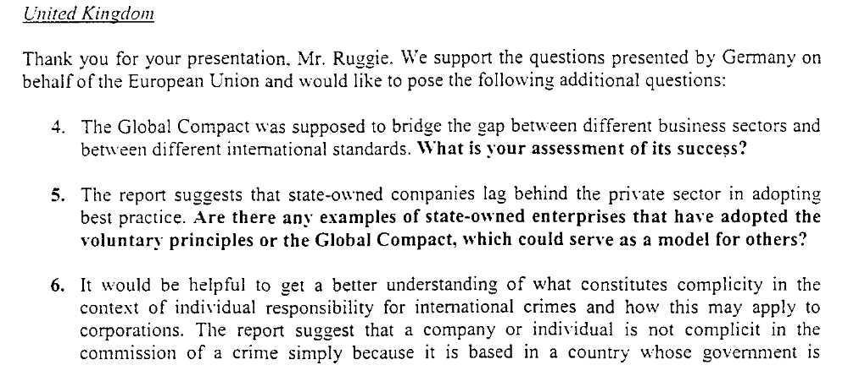

United States of America



