Rejoinder from Ole Wolff Yantai trade union to Ole Wolff’s response
10 Oct 2008
The Business & Human Rights Resource Centre invited Ole Wolff Electronics to respond to articles raising concerns about union rights abuses in its factory in China. The articles are available here:

- “Chinese workers blog vs. Danish factory”, Peter Rasmussen in the website of 3F, United Federation of Danish Workers, 21 August 2008:
http://forsiden.3f.dk/article/20080821/INTERNATIONALT/839981340
- “Danish factory accused of union busting in China”, Peter Rasmussen in the website of 3F, United Federation of Danish Workers, 21 August 2008:
http://forsiden.3f.dk/article/20080821/INTERNATIONALT/486430696

Ole Wolff Electronics sent a response statement to the Resource Centre, available here:
http://www.reports-and-materials.org/Ole-Wolff-response-re-labour-rights-in-China-23-Sep-2008.pdf (23 September 2008)

Ole Wolff Yantai trade union issued the following rejoinder:

A Reply to Mr. Ole Wolff
Ole Wolff Yantai Trade Union
Mr. Ole Wolff, CEO of Ole Wolff Electronics, released a public statement on September 23, 2008 to defend the record of the company’s subsidiary in Yantai, China. He noted that

“Being a good employer that provides good working conditions has always been a key priority for Ole Wolff Electronics whether it be in Denmark or in China, and we provide all our employees with contracts that have been approved by the Chinese authorities.”

This is a lie. Let us recall just how our acting chairperson, Jiang qianqiu, was being fired by Ole Wolff Yantai, and readers will understand just how good the working condition of this factory was. She was fired in June 2007 for asking the management to improve the working condition there. The workers were made to clean electronic spare parts with benzene, bared handed and without any protective devices. Benzene is a kind of carcinogen chemical. The workers had been suffering from dizziness and vomiting because of the management’s negligence of occupational safety.

Mr. Ole Wolff speaks about contract. The fact is that, before the founding of our union, only a few workers among a work force of a little more than one hundred had a contract. After the founding of our union and through our effort, the management did provide workers with contract, but they still tend to manipulate things so as to cheat the workers. When they want to illegally dismiss workers they will just alter the contract unilaterally. Attached is a photo which shows the contract of Wang Liyan, with the contract period being altered by correction pen. The contract started on April 4, 2008 and should have ended on Dec 31 2008. But the management, in order to fire her ahead of the scheduled time illegally, altered the ending date to Oct 8, 2008. The mark of alteration is visible in the photo (see below). The same thing has happened again and again, earlier it was Sun Hua and Ning Xiaonan.

At the beginning, the company simply withheld the copy of the contract which workers are entitled to keep. When this is not an option, the company will then just altered the contract so as to dismiss workers before the contract end.

Mr. Ole Wolff denied that the Ole Wolff Yantai refused to recognize our workplace union. The fact was that the management once told our chairperson that they would not recognize our union because it was found through strike action. Mr. Ole Wolff might not know what his subsidiary has been actually doing or saying. But did he aware of the fact that his subsidiary illegally dismissed our acting chairperson when she stood up for her fellow workers’ rights? Was this a good piece of evidence of recognizing a union? Through the effort of our union, the local labor bureau eventually step in and issued an order to the company in October 2007, and told the company that the dismissal amounted to retaliation against Jiang as acting chairperson of the union, that her action to defend workers’ rights were justified, and demanded the company to reinstate Jiang qianqiu within three days. Yet the company simply ignores the bureau’s order until today. Jiang, the acting chairperson of our union, remains outside of the company. Is this what Mr. Ole Wolff means when he said his company recognizes our union?

Mr. Ole Wolff goes on to deny that the dismissed six had anything to do with their union activity. Technically he is right, because right before the union was founded on October 20, 2006, the six were already dismissed on October 8, and never had a chance to join the union. However, in substance their dismissal was still directly related to union activity, because it was their effort in trying to found the union that led to their dismissal. The Fushan District court’s verdict on the case of the dismissed six confirmed this. Let us quote in length:

“The Fushan District Court ruled that the work record provided by the company cannot be accepted as evidence as it was made unilaterally and cannot verify the company’s claim. The Six struck because the company refused to allow them to found a trade union, and their action was legitimate. Therefore they cannot be regarded as missing work without permission. Therefore the company’s dismissal does not have legal grounds and should be rejected. The Fushan District Court passed its verdict on August 20th 2007 which ruled that:

The company’s decision to terminate labor contract with the Six should be rejected.
The company should pay the Six 520 yuan for the arbitration fee. The Court cost should also be borne by the company.”

However, Ole Wolff Yantai has ignored the court’s order to reinstate the six. Most of the six workers had been unemployed for a long time and therefore they are justified for demanding compensation for the loss of income.

Mr. Ole Wolff denied that they “withheld the workers’ letters of resignation and that this has prevented them from finding new jobs”. Of course Ole Wolff Yantai had not withheld workers’ letters of resignation! They withheld something more important, namely worker’s employment file, in addition to refusing to provide the dismissed six official notification of termination of labor contract.

According to China’s laws, when employers terminate contract with employees, they must:

Provide workers with a notification of termination of labor contract, without which no new employer can hire the workers.

Transfer workers’ employment file (which includes personal history, employment history, recorded merits and penalties, criminal records [if any], social insurance contribution etc) to the labor bureau to keep and to transfer to new employers if the workers find a new job.

However, all the dismissed six had not gotten official notification of termination of contract, and one of them (Liu Meizhen) still has her employment file withheld by the company. The company’s action makes these workers very difficult to find new jobs. The workers had approached the company many times to settle the problems but they were just turned away by the company.

Mr. Ole Wolff said they “are speaking directly to the state union in China to ensure that we avoid any repetition of the current situation.” We do not know what it means. We, the Ole Wolff Yantai Workplace Union, are already an official union affiliated to ACFTU, the All China Federation of Trade Unions. If Mr. Ole Wolff is sincere in talking to trade union, he or his subsidiary should directly and seriously negotiate with us rather than with any other third party. Yet up to this date this fails to materialize. This afternoon, when the company is still defying the court verdict and the labor bureau’s order, the management of Ole Wolff Yantai held a meeting for all employees and accused our union for ‘spreading rumors’ of being repressed by the company, resulting in the loss of business and thus dismissal of workforce is unavoidable. This shows that they have no commitment whatsoever to settle the dispute through genuine negotiationl. Yet Ole Wolff Electronics keep telling everybody outside China that they are negotiating with us seriously.

Ole Wolff Yantai has been infamous for pointing accusing finger at us without, however, being able to provide a single piece of evidence. Now, Mr. Ole Wolff tried to defend his subsidiary, without, again, being able to convince readers with any proof. As for us, our claims and demands are well grounded, and we are ready to share these evidences with anyone who has an interest to know.

October 8, 2008

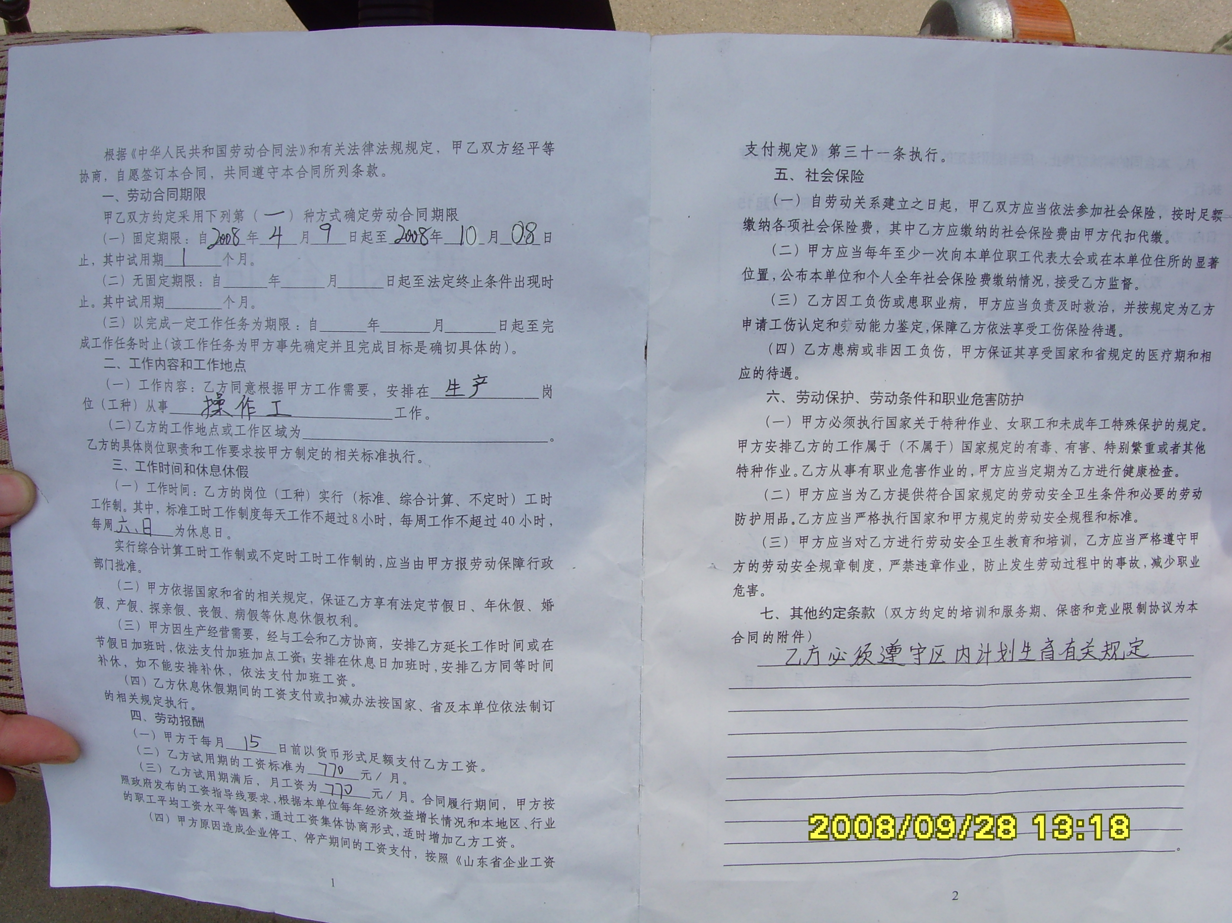
The contract of Wang Liyan. The alteration of the ending date of the contract is visible here.

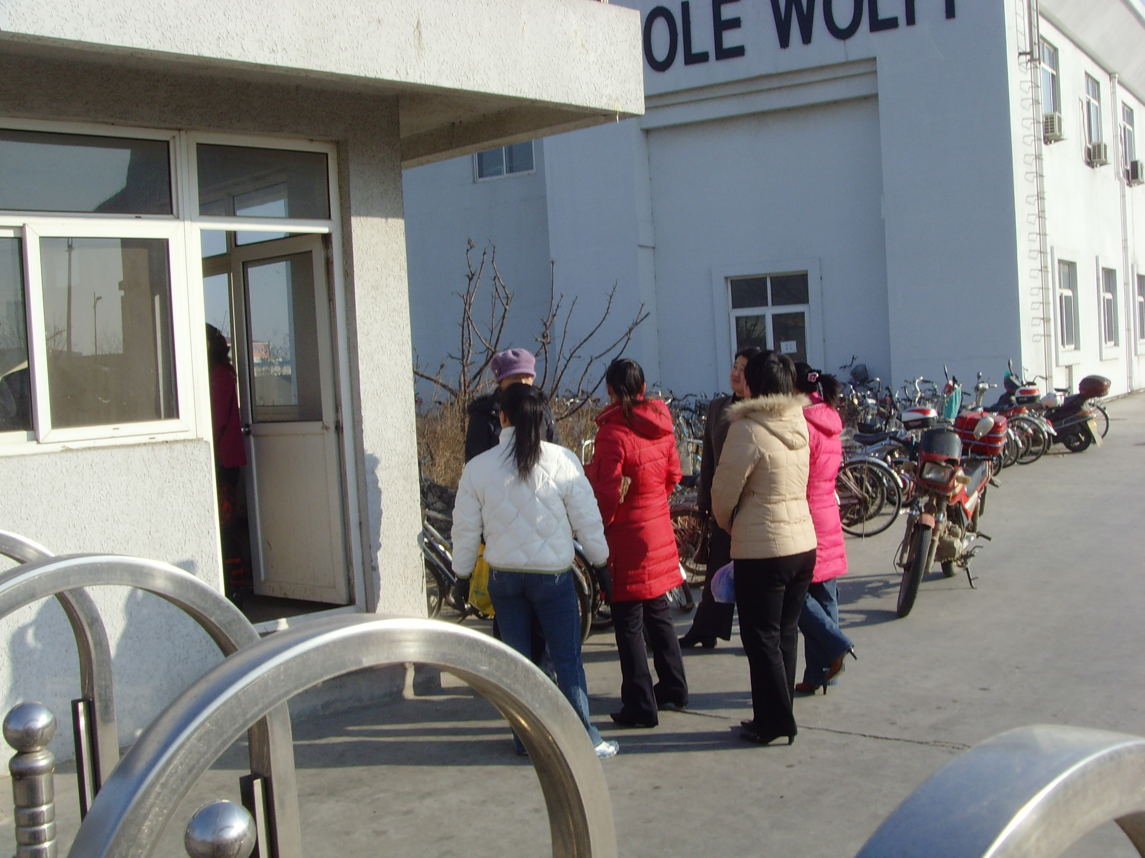
The dismissed six approached the company in July 2007 asking it to implement the court’s verdict of reinstatement. They were barred from the company. In Jan 2008 they went again and were allowed in but the management refused to talk with them.

